**How to search for and play a song in MUSIFY**

**1**

**Navigate to** [**https://musify-2305.vercel.app/**](https://musify-2305.vercel.app/)

**2**

**the new user must signup first and then "Log in" to access the utilities of app.**

**3**

**Click "Log in"**

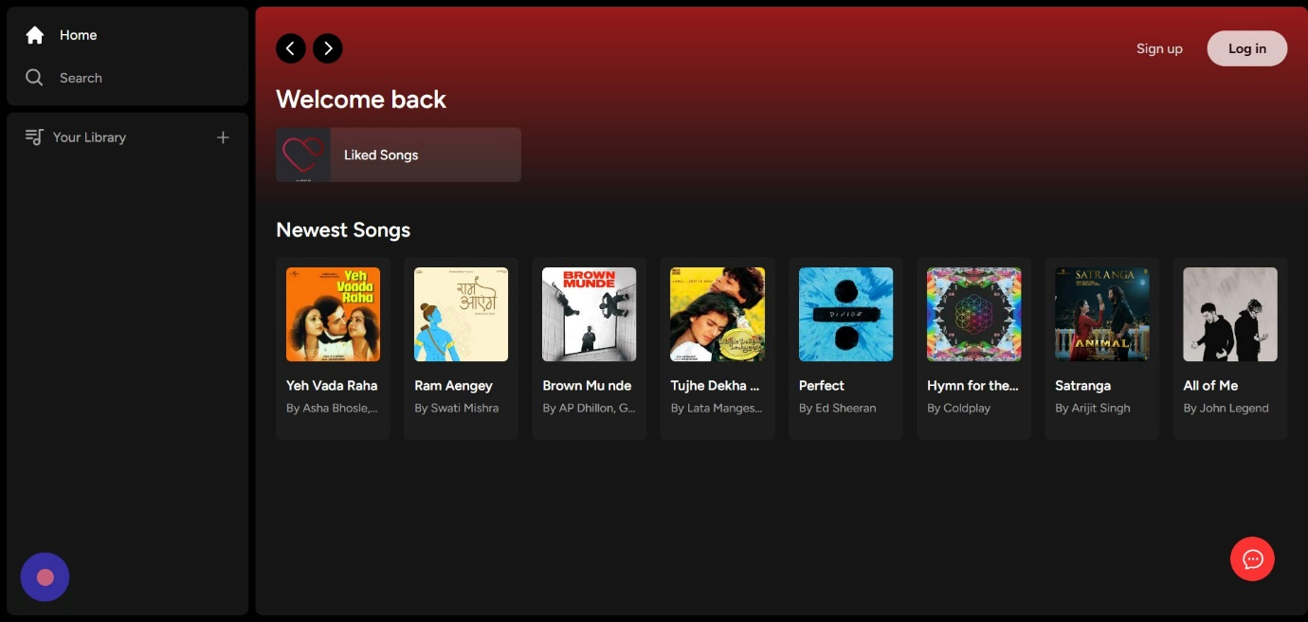

**4**

**Click "Sign in"**

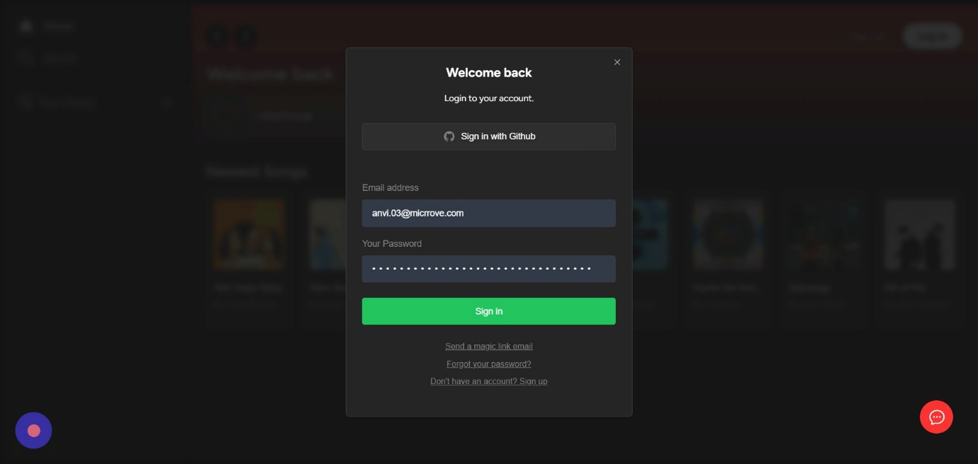

**5**

**Click the yellow button on the right of 'liked songs' to view the liked songs .**

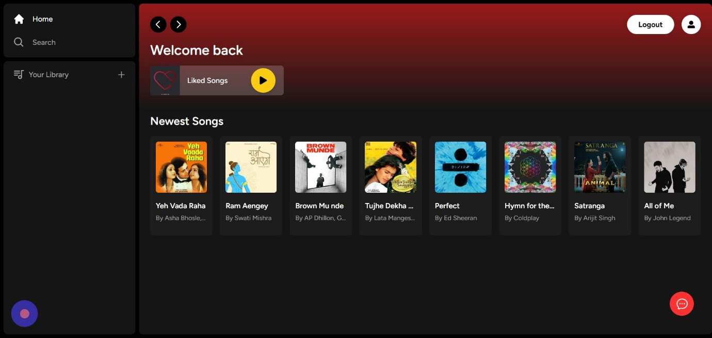

on top **6**

**Click "Home" to return to your homepage .**

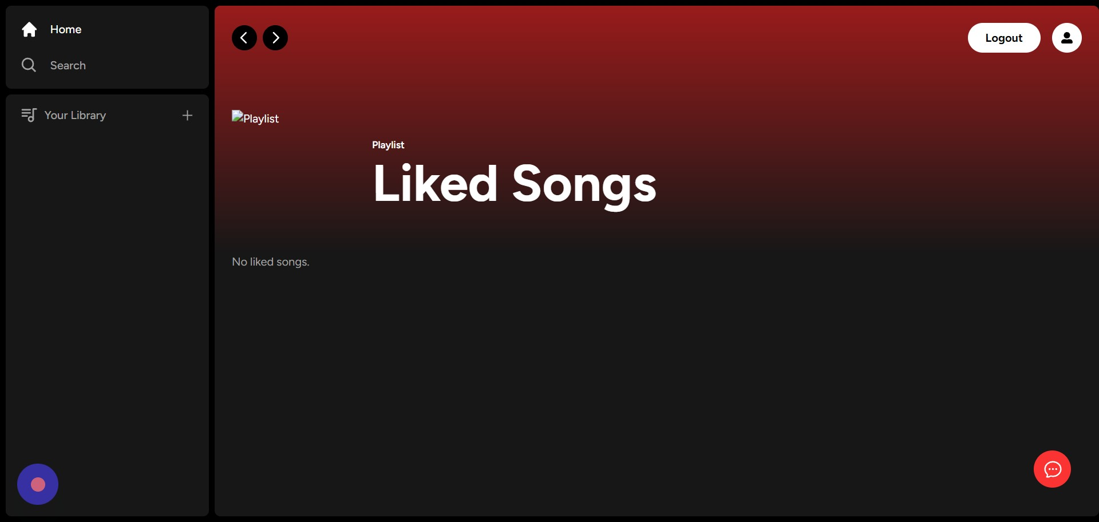

**7**

**Click the the play button of the song to play it**.

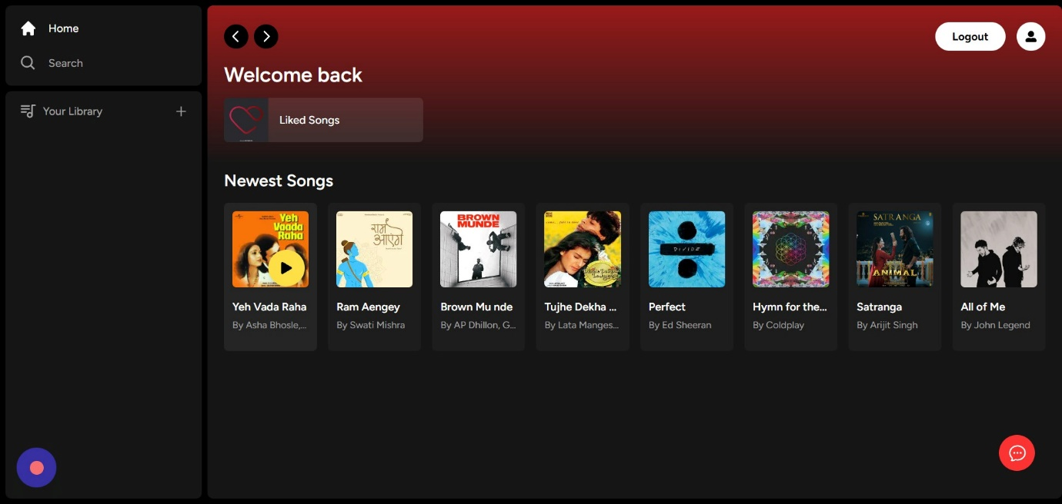

**8**

**Click here to pause or play the song .**

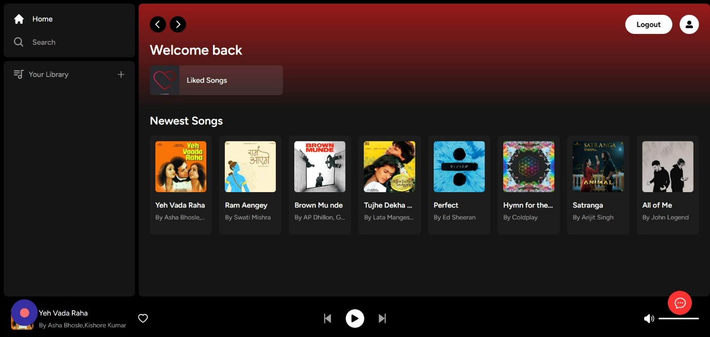

**9**

**Click this icon.**

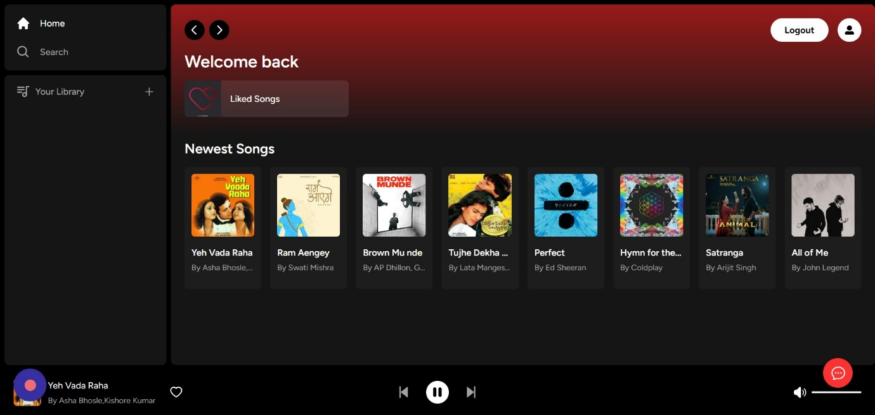

**10**

**Click this icon.**

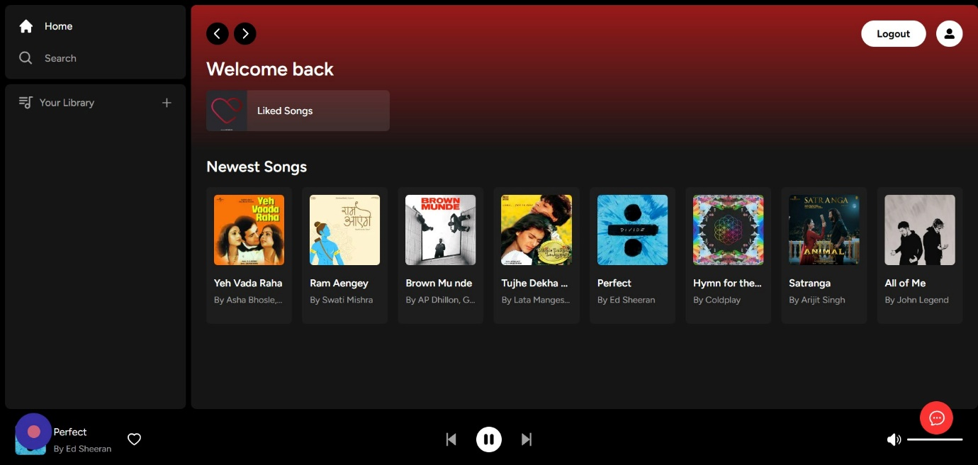

**11**

**Click this volume icon to increase or decrease the volume of song.**

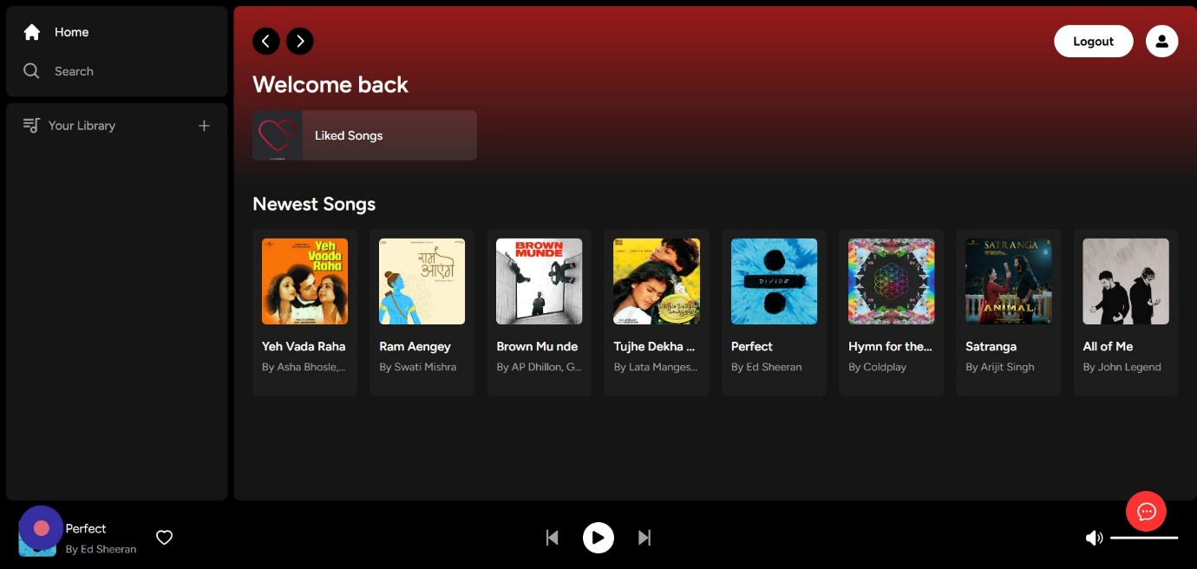

**12**

**Click this '+' icon to add a song to playlist.**

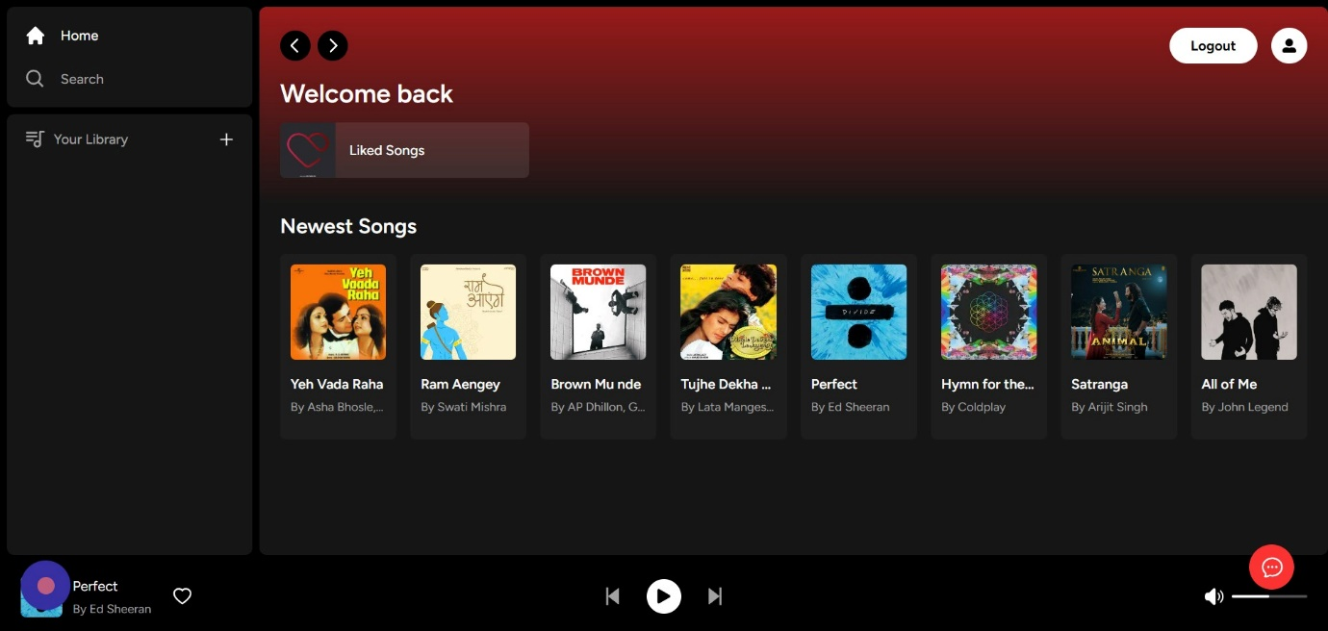

**13**

**Click "Home**

**Search**

**Your Library**

**Logout  
Welcome back**

**Liked Songs**

**Newest Songs**

**Yeh Vada Raha**

**By Asha Bhosle,Kishore Kumar**

**Ram Aengey**

**By Swati Mi..."**

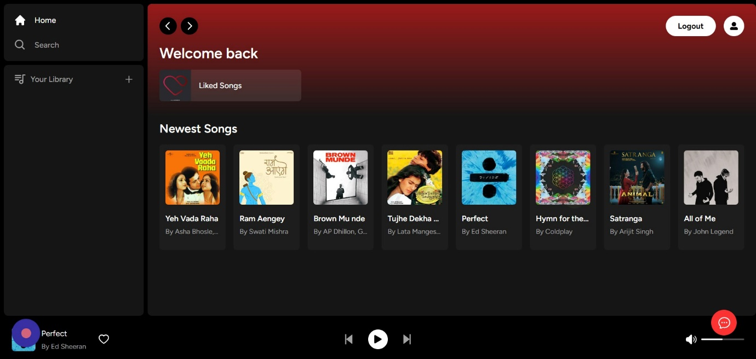

**14**

**Click "Search" for the songs in your playlist.**

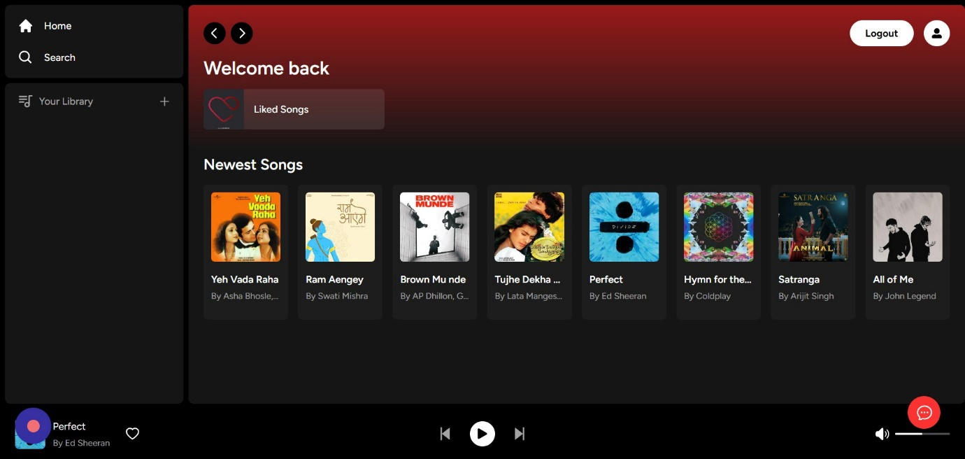

**15**

**Click the "What do you want to listen to?" field.**

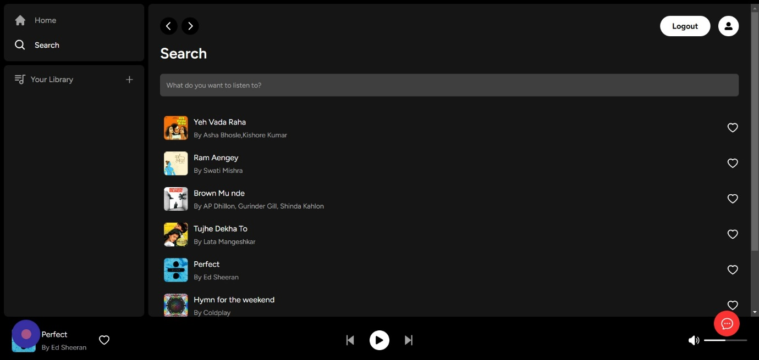

**16**

**Click this 'heart' icon to like a song and to add to your 'liked songs'.**

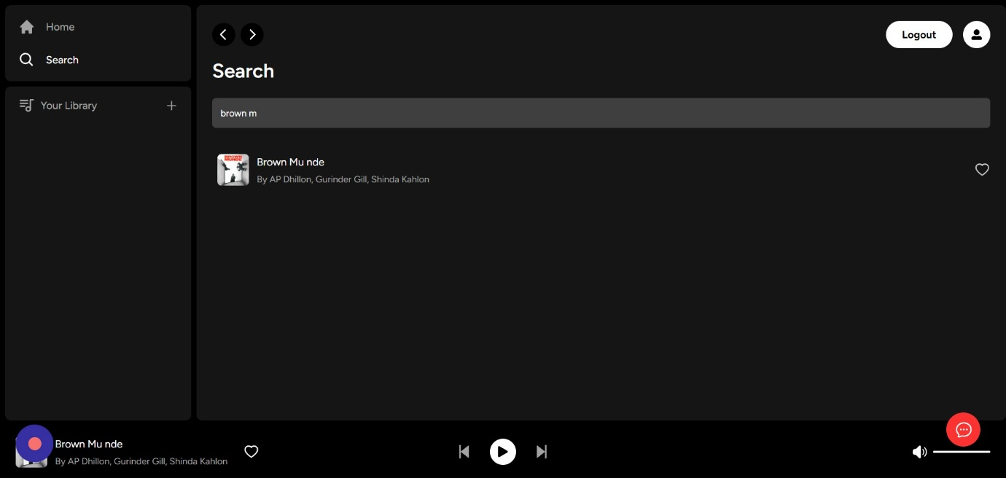

**17**

**This is the AI chatbot to help you out with your queries and assist you.**

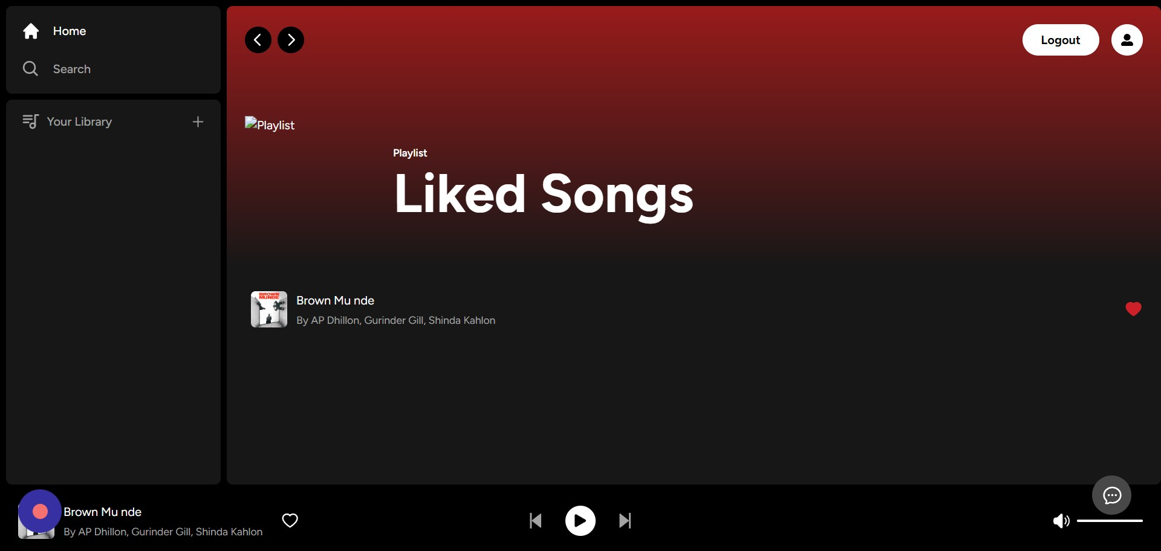

**18**

**Click the "Chat with KRAYO" field.**

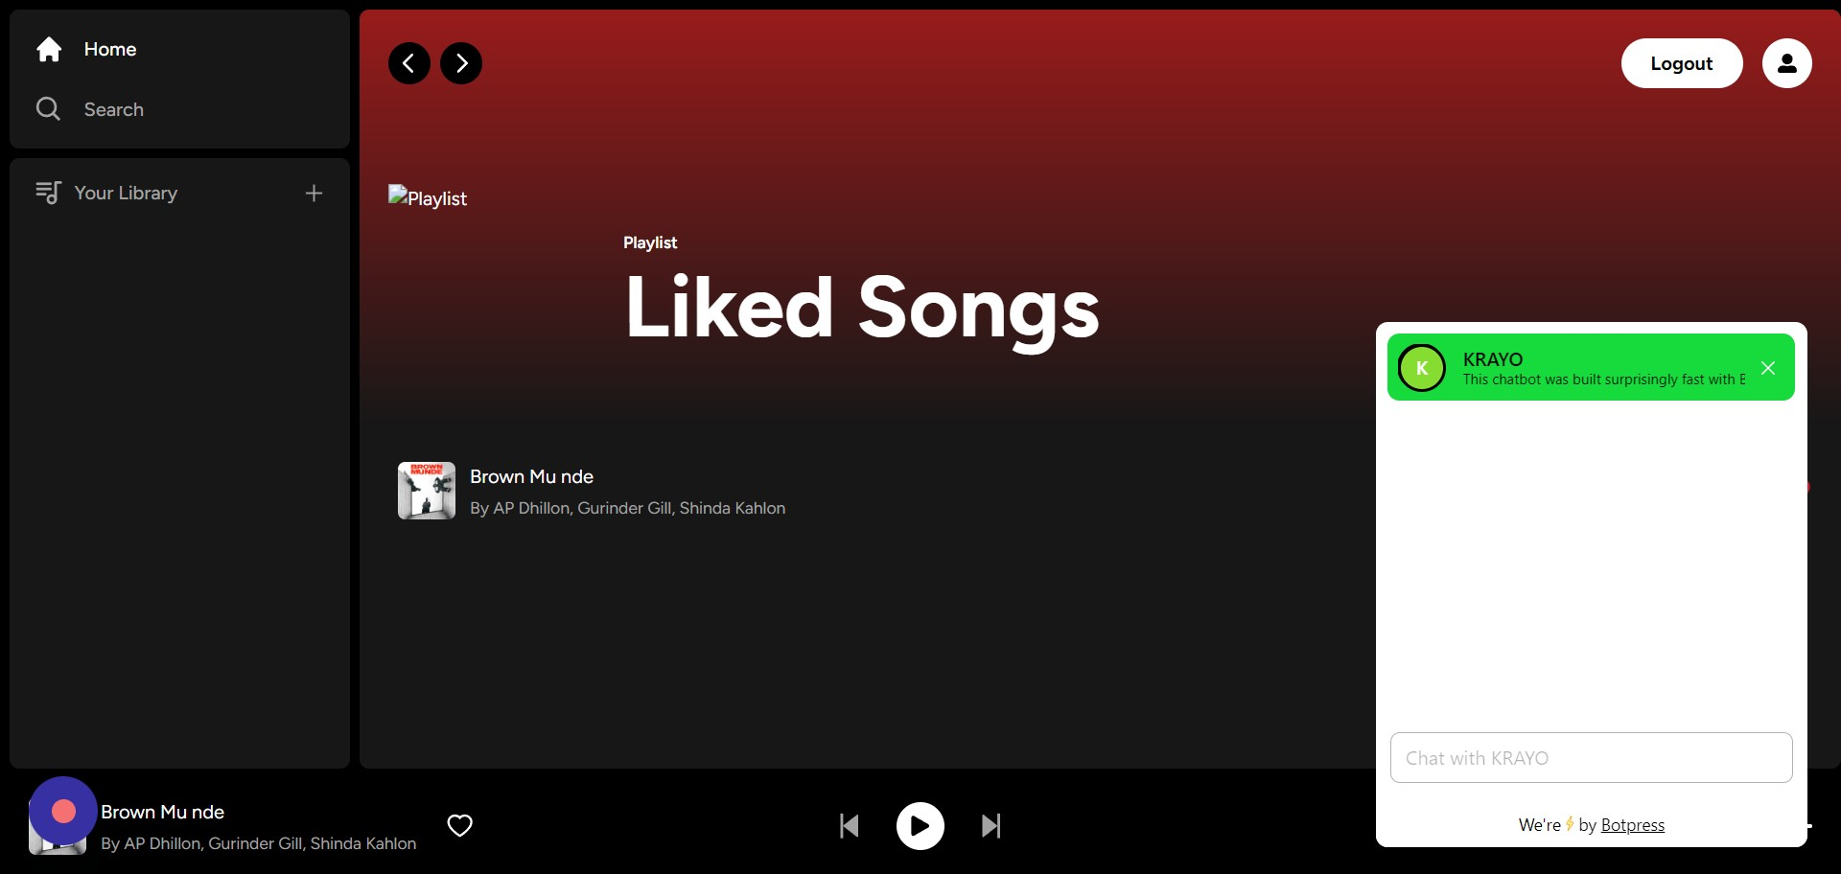

**19**

**you can search songs or talk with the AI powered Bot.**

